Butterfly Valve
Operation Manual
1. Scope
This manual covers manually-operated, gear-operated, electric, and pneumatic butterfly valves with flange and wafer-style connections, in nominal diameters DN50 mm to DN1,600 mm (2" to 64") and nominal pressures PN1.0 MPa to PN4.0 MPa (ANSI Class 150 to 300).
2. Purpose
2.1 Primarily used to open or close the medium in pipes and equipment; also for regulation, throttling, and check (one-way stop) service.
2.2 Valve body material shall be selected based on the medium.
2.2.1 Carbon steel valves — suitable for water, steam, and oil media.
2.2.2 Stainless steel valves — suitable for corrosive media.
2.2.3 Cast iron valves — suitable for water and gas media.
2.3 Operating temperature is determined by the seat material:
PTFE (Polytetrafluoroethylene) seat ≤ 130°C
Stainless steel + composite seat ≤ 425°C
Rubber seat ≤ 60°C
3. Structure
3.1 The basic structure of the butterfly valve is shown in Figure 1.
3.2 Packing for wearing parts uses PTFE or flexible graphite, providing reliable sealing.
4. Operation
4.1 Manually operated valves use a handle or gear transmission. Electric or pneumatic butterfly valves are driven by their respective actuators, rotating the disc 90° to open or close the valve.
4.2 For manually operated valves (including those with a manual override on the actuator), unless otherwise specified in the order contract, when facing the handwheel or handle: turning clockwise closes the valve.
4.3 The open/close position indication for electric and pneumatic butterfly valves is shown by the position indicator on the actuator.
5. Storage, Maintenance, Installation, and Use
5.1 Valves shall be stored indoors in a dry and ventilated area; both pipeline openings shall be sealed.
5.2 Valves stored long-term shall be inspected periodically; remove debris. Pay special attention to keeping the sealing faces clean to prevent damage.
5.3 Before installation, verify that the valve markings match the service requirements.
5.4 Before installation, inspect the valve bore and sealing faces; if any contaminants are present, wipe clean with a soft cloth.
5.5 Before installation, verify that the packing is compressed; ensure it seals properly while not obstructing stem rotation.
5.6 When tightening connection bolts during installation, torque shall be applied evenly and to the appropriate level.
5.7 This butterfly valve can be installed on horizontal or vertical pipelines. Installation location shall allow convenient operation, maintenance, and replacement.
5.8 When manually opening or closing a valve, use the handle; do not use auxiliary levers or other tools.
5.9 Valves in service shall be inspected regularly. Check the sealing faces for wear and inspect packing and gaskets. If damaged or failed, repair or replace promptly.
5.10 For the storage, maintenance, installation, and use of electric and pneumatic actuators, refer to the "Valve Electric Actuator Manual" and "Valve Pneumatic Actuator Manual."
6. Possible Faults, Causes, and Resolutions — See Table 1
Table 1 Possible Faults, Causes, and Resolutions
Possible Fault | Cause | Resolution
Leakage | 1. Incorrect installation | 1. Reposition butterfly valve so both pipe flanges are centered and aligned  2. Tighten connection bolts evenly with appropriate torque
 | 2. Valve not fully closed | 1. Check that the opening indicator shows fully open/closed position  2. Adjust actuator per its manual so indicator matches actual position  3. Inspect and remove any debris or obstruction in the pipeline
 | 3. Valve parts damaged  1) Seat damaged  2).Disc damaged | 1. Replace the seat  2. Replace the disc
Actuator mechanism failure: | 1. Drive key damaged or fell out  2. Taper pin sheared off | 1. Replace the drive key  2. Replace the taper pin
Electric / Pneumatic Actuator Fault | See "Valve Electric Actuator Manual" and "Valve Pneumatic Actuator Manual"
7. Warranty
The manufacturer provides warranty for valves placed into service for up to one (1) year from start of use, but no longer than eighteen (18) months from date of shipment. During the warranty period, any failures attributable to product quality will be repaired or have parts replaced at no charge.

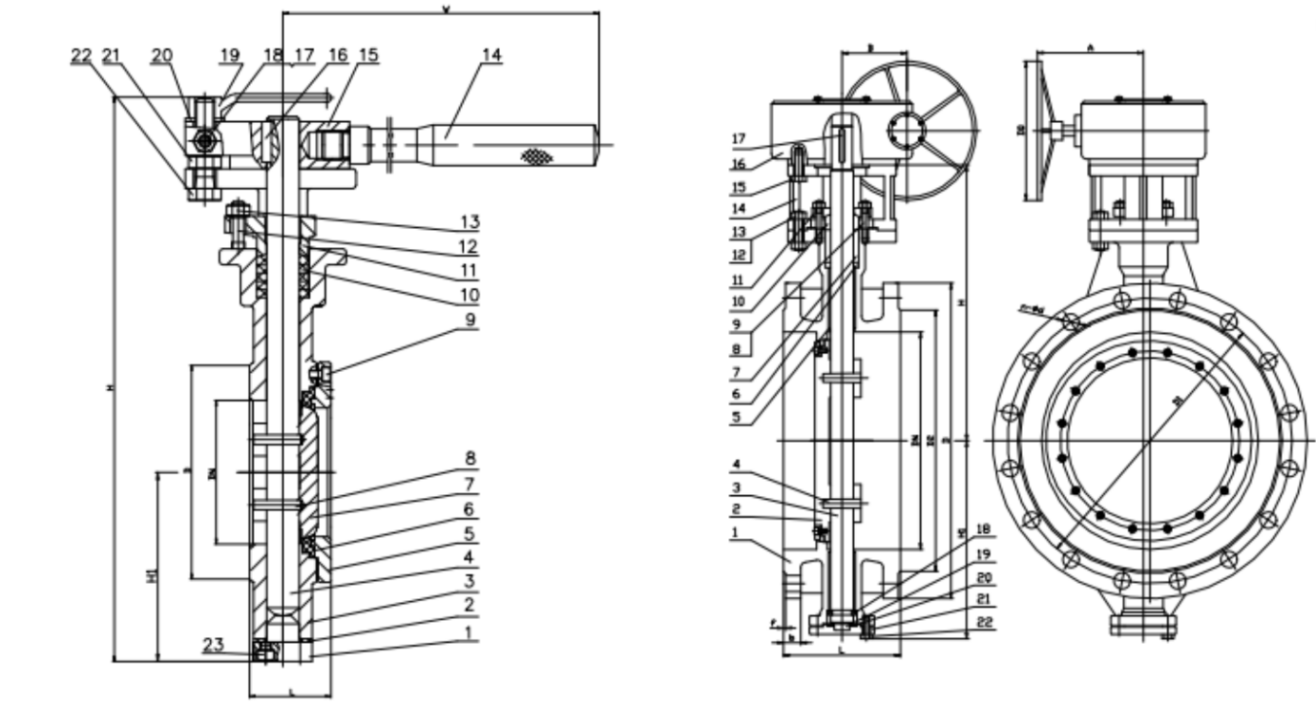
Figures 1 & 2 Butterfly Valve Structure


WEIZIDOM GROUP
www.wsdvalves.com
South City, Longhu Town, Xinzheng City,
Zhengzhou City, Henan Province, China

